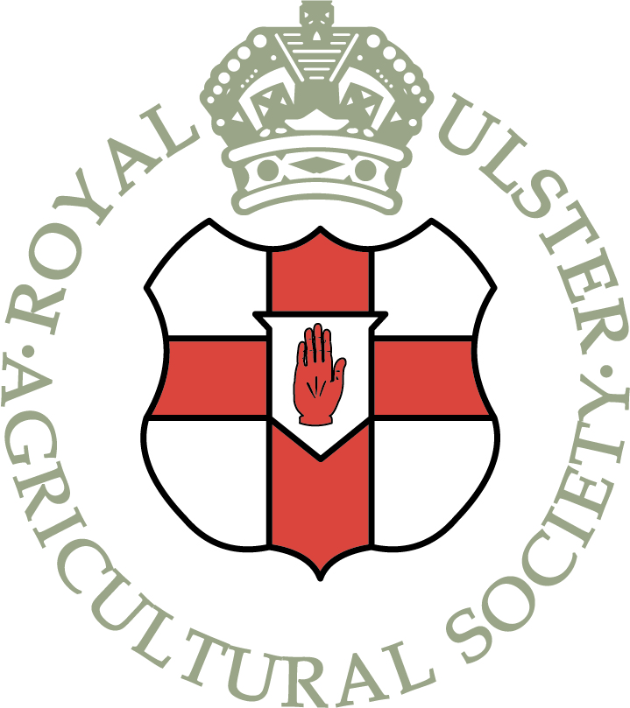

The Royal Ulster Agricultural Society seeks to appoint the following role:-

TRAINEE EVENTS ADMIN ASSISTANT

Job specification and application form available from the Balmoral Show website
www.balmoralshow.co.uk

Completed application form and Fair Employment Questionnaire to be returned to Rhonda Geary, Operations Director rhonda@ruas.org.uk no later than Friday 14th May 2021.

The Trainee Events Admin Assistant role is based at the Eikon Exhibition Centre, Balmoral Park, Lisburn.

JOB SPECIFICATION

Post: Trainee Event Admin Assistant

Contract: Full time (36.5 hours per week)

Reporting to: Operations Director

Salary: Initial starting salary will be in line with the National Living Wage

Main duties and responsibilities include :-

- Assist with processing livestock entries for the livestock Shows
- Assist with compiling exhibitor packs and mailings
- Administration of a number of Balmoral Show competitions
- Ordering of various equipment required for the events
- Creating the Schools Trail and managing the school bookings for Balmoral Show
- Organizing various hospitality and entertainment during the Balmoral Show and Winter Fair
- Organizing various welfare elements for events including show guides; welfare staff and baby changing facilities for events
- Managing the Society portfolio of cups
- Assisting with social media
- General administration
- Managing telephone calls and directing as required ( receptionist duties)
- Assisting in the Show office during events
- Any other appropriate duty as required

Trainee Event Admin Assistant- Person Specification
Essential experience, skills and qualifications

1. A recent proven track record of working effectively in a role that demands building positive relationships with customers.

2. Ability to plan and prioritise workload to meet Event’s needs.

3. Effective problem-solving and judgment.

4. Flexibility in a small team environment.

5. Self-starting and initiative in a small team environment.

6. Maintaining confidentiality in sensitive business issues.

7. Good communication skills, both verbal and written, with the ability to communicate confidently and in a professional manner.

8. Good IT Skills, proficient in Microsoft (Word, Excel, Powerpoint and Outlook)

9. GCSE English and Maths at Grade C or above (or equivalent).

