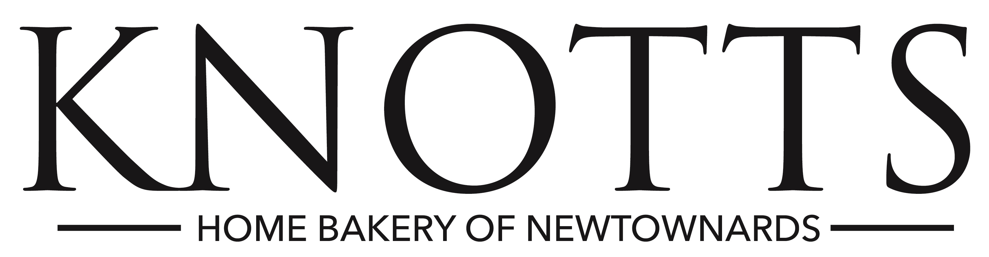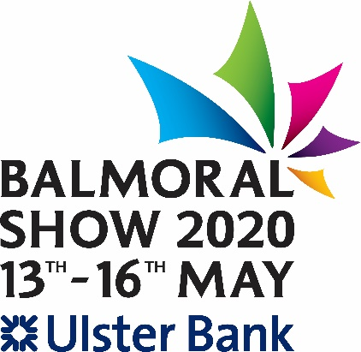

**KNOTTS BAKERY YOUNG EVENT HORSE CHAMPIONSHIP**

**Entry Fees: RUAS Member £85.00, Non Member £90.00**

*\*\*\* Stabling is included in the entry fee on the evening before the class only \*\*\**

**AIM**

To identify high class horses bred in Ireland with the potential to become top class eventers, to create a medium for breeders and producers to display their quality young stock and to encourage breeders and trainers to produce and present the correct type of horse likely to make a top class three day eventer.

**COURSE DESIGNER: ADRIENNE STUART**

**DATE  
  
THURSDAY 14 MAY - In the Main Arena**

Phase 1. DRESSAGE. Max available 30% of total

Phase 2. CONFORMATION AND TYPE.  Max score 10% of total

Four year olds followed by five year olds.

Phase 3. JUMPING.   Max score 45% of total

Phase 4. SUITABILITY AND POTENTIAL.  Max score 15% of total

**Phase 1.  DRESSAGE TEST**

Marks will not be awarded for individual movements but the test will be marked for general impression and overall performance.

Test to be ridden from memory.

Arena size 60m x 20m.

A                              Enter in working trot

From X proceed directly to

M                             Working trot

C                             3 loops serpentine finishing at A

FXH                         Change rein showing some lengthened strides (not required for 4 year olds)

Between H& C          Working canter right

C                         Circle right 20m diameter

MXK                    Change rein with transition to trot between X and K

Between K&A          Working canter left

A                             Circle left 20m diameter

Between A&F            Working trot

Between F&B          Medium walk

B                             Half 20m circle left in free walk on a long rein

E                             Medium walk

Between E&K           Halt & salute

                             Leave arena at A

On completion of Phase 1. Riders should proceed directly to their jumping phase.

**Phase 2. JUMPING.**

Class                           4 Year olds                       5 year olds

No of fences                     16                                    18

Max height cms.                 90                                   100

Course length m                800 - 1000                        1000 - 1200

Knock of pole                   4 penalties

1st Refusal/Run Out             5 penalties

2nd Refusal on the course    8 penalties

3rd Refusal on the course     Elimination

Fall of Horse or Rider          Elimination

**Phase 3.  CONFORMATION & TYPE.**

Horses must be presented on the triangle for their conformation and movement assessment.

It is desirable that the presentation of animals at the triangle is properly rehearsed as follows.

*The horse will be presented before the judges at A where they will be assessed for conformation and movement.

*Horses should stand square with all four limbs bearing weight.

*Movement will be assessed on the triangle.  The exhibitor will be asked to walk and trot their animal around the triangle approx (25m x 40m x 25m) in a clockwise direction, one round in walk and one round in trot.

*The triangle format allows the judges ( who will be positioned at A) to assess natural paces from behind, side and in front allowing them to easily assess freedom of shoulder, use of back, engagement of the hock, tracking up and straightness in both paces.

A

**Phase 4. SUITABILITY AND POTENTIAL.**

The judges acting independently will assess each horses potential, based on the following criteria:

*Fluency & Balance

*Horse's Attitude

*Suitability of type for purpose

*Gallop - to be shown immediately after last fence is jumped

*Overall impression

These scores will be included in Phase 1, 2, and 3.

The Grand Total will be the horse's final score and will determine its final placing.

In the event of equality of marks, the jumping mark will take precedence.

Should this still produce an equality of marks, the highest mark attained in the final section will be the deciding factor.

**ELIGIBILITY**

Restricted to 'Irish Bred' horses.  Only animals with named passports identifying sire, dam, dam sire, microchip and breeder may compete. Passports will be inspected before Phase 1.

Horses must exceed 148cms without shoes.

Open to horses foaled in 2016 and 2015.

To be ridden by riders who have attained their 16th birthday by 1st January in the current year.

Horses must have competed in two qualifiers and attained at least 60% in one.

**QUALIFIERS**

**Gransha Equestrian              Tuesday 7 April 2020 (entries close 1 April)**

**Barnadown Equestrian Centre Thursday 9 April 2020 (Entries close 2 April)**

**Portmore Equestrian Centre Tuesday 14 April 2020 (Entries close 8 April)**

**Meadows Equestrian Centre Tuesday 21 April 2020 (Entries close 15 April)**

**Lusk Equestrian Centre Tuesday 28 April 2020 (Entries close 22 April)**

**Qualifier Entry Fee: £50 / €60**

**ENTRY FORM**

Completed entry form and fee must be sent to [carolyn@ruas.org.uk](mailto:carolyn@ruas.org.uk) before close of entry (see above) Entry forms available at [www.balmoralshow.co.uk](http://www.balmoralshow.co.uk)

The top **4** horses in each class at each qualifying venue will qualify for the final on 14th May at Balmoral Park providing they have attained a minimum score of 60%.  If any of the top 4 horses have already qualified, horses down the line may qualify providing they have also attained a minimum score of 60%.

**RIDERS CAN RIDE THREE HORSES PER CLASS IN THE FINAL**

Tack:

*Snaffle bridles as defined by FEI are mandatory with any one of the following permitted nosebands: cavesson, drop, flash or grackle

*Neckstraps and/or breastplates are permitted

*No standing martingales are allowed

*Numnahs (if used) must conform neatly with saddle contours

*No saddlecloths or logos are permitted other than the competition sponsors.

*Hind leg boots or bandages are not allowed in any phase of this competition. Overreach boots are permitted and no performance-enhancing front boots are permitted.

*Only blunt metal spurs or ones with rubber rowels < 2.5 cms facing downwards are permitted

*Riders should wear

Eventing colours and attire.

Beige, fawn or cream breeches

Long black boots

Gloves

Protective headgear conforming to the current recommended kitemark standard - PAS 015 or  EN1384 and fitted with an adjustable harness

A body protector must be worn by all riders during Phase 1 and 2.

**CLASS**

**57           FOUR YEAR OLD YOUNG EVENT HORSE**

**58           FIVE YEAR OLD YOUNG EVENT HORSE**