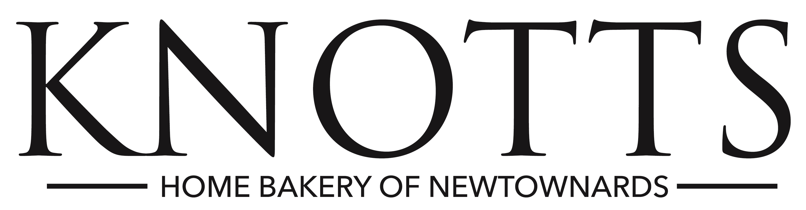

Young Event Horse Qualifiers

Entry Form

Lusk Equestrian Tuesday 2 April 2019
Meadows Equestrian Centre Tuesday 9 April 2019
Ravensdale Equestrian Centre Tuesday 16 April 2019
Gransha Equestrian Centre Tuesday 23 April 2019

Entry Fee: £50
Close of entries: 5.00pm on the Sunday preceding each qualifier date.
Late entries £60 accepted at the discretion of the organiser.

Completed entry form and fee must be sent to the appropriate qualifying centre before the close of entry.

Qualifying Venue |  | Date
Name of Rider
Name of Owner
Name of Horse |  | Age
Sire |  | Entry Fee Enclosed  £ __________ or  € __________
Sire of Dam
Address of Owner/Agent
Telephone No
Email

Top five horses in each class at each qualifying venue will qualify for the final on Thursday 17th May at Balmoral Show providing they have attained a minimum score of 60%.

Riders can ride three horses per class in the final.

Full competition details can be found in the Balmoral Show Prize Schedule available online at www.balmoralshow.co.uk

